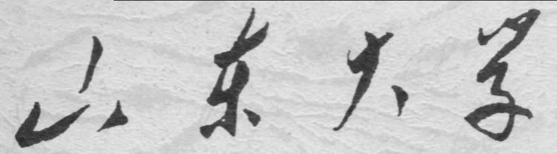

崇新学堂

2025－2026学年第一学期

实 验 报 告

课程名称： 电子信息工程导论
实验名称： Robot Pets

专 业 班 级 崇新学堂
学 生 姓 名 高子轩，钱竹玉，吕思洁，徐亚骐
实 验 时 间 2025年11月27日

Pet Robot
Step1: Make a design for the robot to Turn to a strong light source
Here is our assumption
Since the head is mounted on the body, if the head turns to the left, the body should also turn to the left until the head returns to center.
The robot reads the voltage signal from the head potentiometer. When the head turns to one side, the controller outputs the rotational speed rvel to drive the robot's body to rotate in the same direction until the head reverts to a forward orientation relative to the body.
Then, through the proportional controller, calculate the forward speed.
$$rvel=K_{rot}×(V_{neck}-V_{center})$$
Check Yourself 1 Identify the key variable in head control that determines the distance to light
The neck potentiometer can only determine the direction of the light source, not its distance. According to physics principles, light intensity decreases with distance. Therefore, we need to measure the light intensity to estimate the distance between the robot and the light source, which determines whether to move forward or backward.
Our strategy assumption:
First, connect the light intensity signal to analog input pin 5.
• If the light is too dim, the robot stops.
• If the light is too bright, the robot will retreat.
• If the light is moderate, the robot advances.
Through that we can maintain a distance of about 0.5 meters.
Step 3 Combining Light Tracing State Machine and Boundary Following State Machine
Here is the key code
rot_error = neck_voltage - NECK_CENTER_VOLTAGE
rvel = rot_error * K_ROT
if light_voltage < LIGHT_OFF_THRESHOLD:
fvel = 0
elif light_voltage < TARGET_DISTANCE_VOLTAGE:
fvel = 0.1
else:
fvel = -0.1
if light_voltage > LIGHT_DETECTED_THRESHOLD:
return light_following_behavior(inp)
else:
return boundary_follower_behavior(inp)

Switch logic
The system monitors the light intensity and sonar reading in real time.
Scenario A: When the light is sufficiently strong and the path is unobstructed, the system switches to Light Following mode.
Scenario B: When light is dim or unavailable, switch to wall-following mode.
Appendix1: Some content description
Since this experiment cannot be conducted on actual vehicles or through simulations, we have made numerous assumptions in the article, relying on intuition and conjecture to address certain questions.
Appendix2: The Description of AI Usage in the Report
Since real testing was not feasible, we employed AI to infer unknown scenarios in this experiment and responded based on its explanations.

